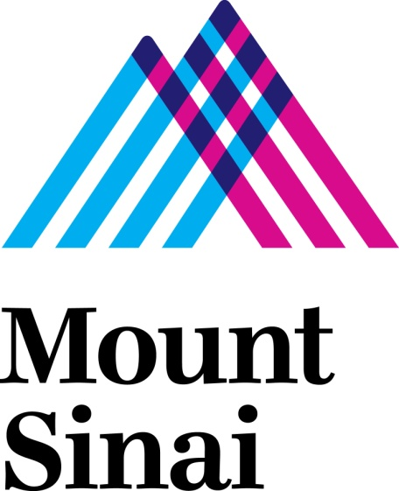

TO: Hospital Sponsored Programs Office for:
Mount Sinai Beth Israel
Mount Sinai Hospital
Mount Sinai St. Luke’s
Mount Sinai West

FROM: Project Director
Administrative Contact (if applicable)
Project Director’s Site/Hospital

DATE:

RE: PROJECT DIRECTOR CERTIFICATION

Please submit a PROJECT DIRECTOR CERTIFICATION FORM with initial grant or contract submissions only when Icahn School of Medicine at Mount Sinai is NOT an eligible applicant. Please return the completed form to OGARA@chpnet.org

The PROJECT DIRECTOR CERTIFICATION is a three part form:

- The cost status section outlines anticipated cost/funding sources and documents Chair certification. When the project involves staff from more than one department, please use the second Chair certification section to indicate review and authorization from all involved departments.

- The checklist section requests specific information for all projects, with specific subsections for authorization requirements based on the type of project.

- Project Director certification.

Please contact the Mount Sinai Health Systems Hospital Sponsored Programs Office with any questions or concerns. Please submit completed form to OGARA@chpnet.org
DEPARTMENTAL COST CERTIFICATION - CHAIR AUTHORIZATION SECTION

Project Title:
Sponsor ID Number (if any):
Sponsor (if applicable):
Check One:
All costs are fully explained within the related agreement and budget.
If the project includes cost sharing, documentation of the authorized source and amount of cost sharing is attached.
I certify that the project is consistent with the mission of the Department and the institution, and that Departmental resources will be available to implement the project consistent with the intent of the proposal/agreement and this Project Director Certification form.

Print/Sign Date
Department Chair or Chair Authorized Designee

SECONDARY DEPARTMENT COST CERTIFICATION - CHAIR AUTHORIZATION SECTION
USE THIS SECTION ONLY IF MORE THAN ONE DEPARTMENT IS NOTED ON THE RELATED BUDGET

I certify that the project is consistent with the mission of the Department and the institution, and that Departmental resources will be available to implement the project consistent with the intent of the proposal/agreement and this Project Director Certification form.

Print/Sign Date
Department Chair or Chair Authorized Designee

CHECKLIST SECTION

ALL PROJECTS COMPLETE THIS SECTION
Does the project involve interventional activities in which project-required services (i.e. routine care services) will be billed to patients or third party payers? If yes, complete the MEDICARE COVERAGE ANALYSIS/RESEARCH BILLING CHECKLIST form.

For projects involving human subjects including data, has the PPHS/IRB APPLICATION process been engaged?

Is this project sponsored by New York City or New York State? YES/NO If so, is it subject to Minority and Women-Owned Business utilization requirements? YES/NO See related regulations and guidance.

Status indication - New, Renewal, Continuation, Supplement, Revision, No-Cost Extension, Other

Project period - All years, if applicable

Amount - All years, if applicable.

Attach BUDGET showing all years (use sponsor-required form). It is institutional policy to collect full Facilities &Administration and fringe benefit rate costs from all funding sources. See ADMINISTRATIVE INFORMATION SHEET for specific costs and rates applicable to your project.

Is a subcontract/application involved? Is the hospital the prime applicant or prime contractor? If so, supply the name(s) of any sub-entity. Is the hospital a sub-applicant or subcontractor? If so, supply the name of the prime entity. For sub-applicants / subcontracts under the hospital as the prime, attach scope, budget, proposal and approval/Letter of Intent from subcontract institution if applicable.

Does the project narrative or budget involve cost-sharing (including in-kind) commitments? If yes, please complete COST SHARING FORM

SPECIAL PROJECT AUTHORIZATIONS
Is this a QUALITY IMPROVEMENT activity? YES/NO
If yes, has hospital or system Quality Management Director reviewed and approved?

PROJECT DIRECTOR CERTIFICATION SECTION

I certify that I have used all reasonable diligence in preparing this certification statement and to the best of my knowledge the contents are true and complete.

Print/Sign Date
Project Director

